**Predicting Implied Volatility Using Swap Rates to Build Trading Strategy on Fixed Income Products**

By: Louise Henningsson, Tejal Borade, Yi-Hsuan Fan,

Mohammed Aman Mujeeb, Viet Tran, Chinmay Thakre

Professor Chris Kelliher & Professor Eugene Sorets

MF728 Fixed Income Securities

April 29th, 2023

Table of Content

Introduction 2

Exploratory Data Analysis 2

Method 4

**Black's Model for Implied Volatility** 5

Implementation 5

Results 7

Summary 9

References 11

# 

# **Introduction**

This project aims to through swap and swaption data, calculate implied volatilities relating to the swaptions, and through those implied volatilities, develop a trading strategy. The project and methods were divided into separate sections in which we first calculated the corresponding piecewise constant forward rates for the swaps, the annuities for the swaps combined with the swaption expiries, calculating the prices through the Bachelier model, getting the implied volatility through the Black’s model, and lastly constructing a trading strategy.

Implied volatility is a crucial parameter used in financial modeling as it represents the future expected volatility of a swap up until the expiry of the swaption. The implied volatility of a swap changes as the expectations of the volatility change, affecting the swaptions premiums. Therefore, we found it intriguing to explore further how various trading strategies would perform with our implied volatilities combined with the changed expectations.

# **Exploratory Data Analysis**

This project aims to calculate the implied volatility of the swaptions connected to different swaps. Therefore, we collect daily data for the US overnight indexed swap (OIS) for the 5 years period between May 2018 and April 2023 from Bloomberg. We collected swap rates with 1-year, 2-year, 5-year, 10-year, and 30-year tenors which were then used independently to calculate our piecewise constant forward rates for the various tenors matching our swaption expiries. The swaption expirations that we decided to focus on in this project were the 1-month, 3-month, 6-month, 1-year, 2-year, and 5-year expiries. Our calculated implied volatilities were then compared to the realized volatilities in our swaption data and further implemented a trading strategy.

When looking through the data, there were a few days that were missing values. For those days, we decided to exclude the whole day from all datasets. Thereafter, we did an inner join across tenors of the swaps and the expiries of the swaptions, for example, the 1-year tenor swap will have its equivalent 1-month, 3-month, 6-month, 1-year, 2-year, and 5-year expiries joined in the same dataset. Further depicted in *Figure 1* are the five swap rates collected for our project. The swap rates can be seen following the same trends, however, the shorter the tenor of the swap rate, the more volatile the swap is. This is evident in *Figure 1* as the 1-year swap rate moves the most both downwards and upwards while the 30-year swap rate moves the least.

Another notable thing in *Figure 1* is how, from the beginning of 2022 forward, the higher-tenured swaps become lower than the shorter-tenured swaps, essentially switching the order in the graph. Historically, this phenomenon indicates an upcoming recession.

*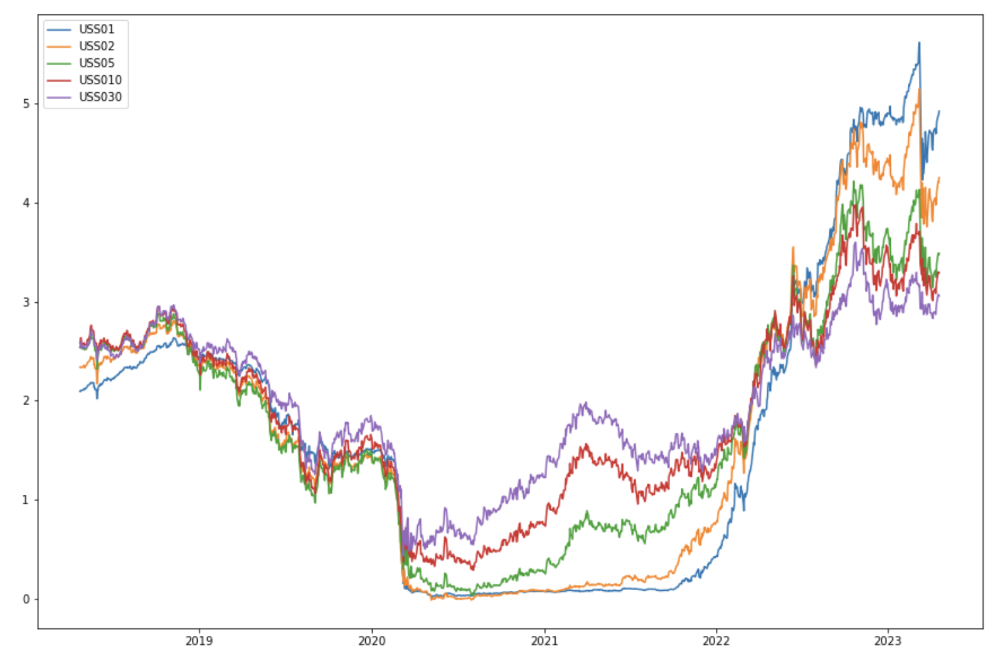****Figure 1: Swap Rates***

# **Method**

In this project, there were four main methods used to calculate the implied volatilities needed to construct our trading strategy. First, we needed to calculate the piecewise constant forward rates corresponding to our swap rates using the following formula:

$$F = delta * log(0.5 * (P/100)+ 1) * 10,000$$

The forward rate is equivalent to the interest rate applicable to a transaction in the future. When calculating our forward rates, we assume each swap has two payments a year, meaning our delta is set to 2. Furthermore, P indicates our five different maturity swaps prices. We ran the function five times to retrieve the piecewise constant forward rates for each swap.

Thereafter, we calculated the annuities for the various piecewise constant forward rates obtained from our first step. The annuity function represents the present value of one basis point of the swaps and is also an input into our next function. The inputs to take into account in the annuity formula are the tenor of the swap, the expiry of the corresponding swaption, and the previously calculated piecewise constant forward rates. Annuities for each swap matched with each swaption expiry were calculated in this step, resulting in a total of 6 annuities.

Using the forward and annuity values that were calculated, we implement the Bachelier model to price the swaption. The following formula defines the call option price under the Bachelier model:

$P = A*σ*\sqrt{T}*d_{1}*Φ(d_{1})+ϕ(d_{1})$

Where d1 is defined as:

Here, F0 is the forward price at time t = 0, K is the strike price, A is the annuity value, 𝝈 is the volatility, and T is the option expiry time. Further, ɸ is the CDF of the standard normal distribution, and 𝛷 is the PDF of the standard normal distribution. (Liu och Xie)

## **Black's Model for Implied Volatility**

Using the swaption prices that were calculated under the Bachelier model, we can compute the implied volatility with the Black-Scholes model by using a root-finding algorithm. The closed-form solution for the call prices under the Black-Scholes model is:

$$P = F_{0}Φ(d_{1})-Ke^{-rT}ϕ(d_{1})$$

Where $d_{1}$ and $d_{2}$ are defined as:

$$d_{1}=log(\frac{F_{0}}{K})+T\frac{(r+\frac{σ^{2}}{2})}{σ\sqrt{T}}$$

$$d_{2}=d_{1}-σ\sqrt{T}$$

In these equations, F0 is the forward price at time t = 0, K is the strike price, 𝝈 is the volatility, r is the risk-free interest rate, and T is the option expiry time. Further, ɸ is the CDF of the standard normal distribution, and 𝛷 is the PDF of the standard normal distribution. The Black’s model will provide us with the implied volatilities for each swap with each swaption expiry, that we will use to implement the trading strategy. (Kelliher)

# **Implementation**

We implemented the Long/Short Moving Average trading strategy as they are straightforward and easy to implement. We can use these in various markets and timeframes which make it ideal for the swaption data we are using. We are using a 50-day and a 200-day rolling window as they are commonly used for moving averages and provide a good balance between sensitivity and stability in identifying trends. This strategy can also help us manage risk by setting stop-loss orders based on the moving averages, thus limiting losses and protecting the capital.

We used a set of conditions to determine where to set a signal to 1 (buy) or 0 (do not buy) in a trading system. This verifies several factors such as the par swap rate, moving averages, and volatilities over a period of time. If the par swap rate is higher than the 50-day moving average, the 50-day moving average is higher than the 200-day moving average, and the volatility is higher than the respective moving average and the difference between them, then the current par swap rate is the previous day's par swap rate. If it is greater than -0.01, the signal is set to 1 (long position). If these conditions are not met, then it checks whether the par swap rate is less than the 50-day moving average is less than the 200-day moving average, the volatilities are less than their respective moving averages, and the par swap rate and volatilities are less than their respective moving averages, and the par swap rate and volatilities from the previous day are less than their respective moving averages. If these conditions are met, then the signal is set to 0 (short position). By analyzing this, we can identify potential opportunities to buy or sell. This system enables us to maximize our profits by helping us make an informed decision about when and whether to enter or exit the market. (Cesari och Marzo)

Our strategy generated on average about 30 long short signals in every trading period to ensure a completely invested portfolio and closing out short positions appropriately.

After implementing the Long/Short Moving Average strategy, we needed to find a way to rebalance our portfolio. A fully invested rebalancing portfolio trading strategy involves buying and selling swaptions regularly to maintain a predetermined portfolio mix. This strategy is designed to help investors to manage risks and maximize returns by ensuring that their portfolio remains well-diversified and properly aligned with their investment goals.

We used Genetic Algorithms to rebalance our portfolio. In our MF708 Final Project, we saw that Genetic Algorithms yielded positive results and beat the S&P 500 index. In the genetic algorithm, we used the Sharpe ratio as an optimizer. This helped us maximize our returns while minimizing our volatility. In the context of swaptions, we created a portfolio of different types of swaptions at various expiries and different tenors, and periodically rebalanced the portfolio to maintain the desired allocation. In the rebalancing, we used returns from our long/short strategy of swaptions to adjust the portfolio’s exposure to different types of risk.

The reason for using this strategy is to manage the exposure to interest rate risk. Swaps and swaptions can be used to hedge against the potential losses due to Interest Rate shifts and to take advantage of market opportunities. (Cesari och Marzo) (Mujeeb, Henningsson och Thakre)

# **Results**

Depicted in *Figure 2* is the 1m1yr calculated implied volatility through our method of first calculating the piecewise constant forward rates, calculating the annuities, then using the Bachelier model to calculate option prices, and lastly calculating the implied volatilities using Black’s model. The blue line in *Figure 2* visualizes our implied volatility. It is evident that the implied volatility follows the same pattern and flow as the realized volatility of the swaption. However, the scales of our implied volatility and the realized volatility are different as there are random variables that we could not account for in our model when calculating the implied volatilities. These variables include the floating leg and the yield curve.

***Figure 2: 1m1yr Figure 3: 3m2yr****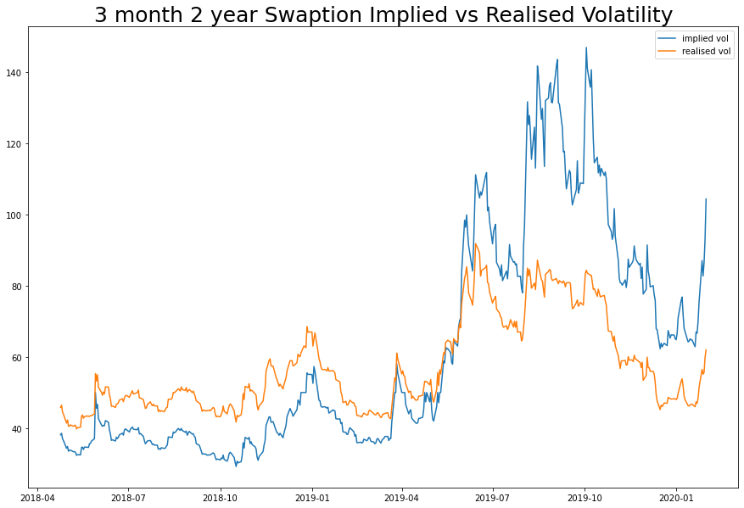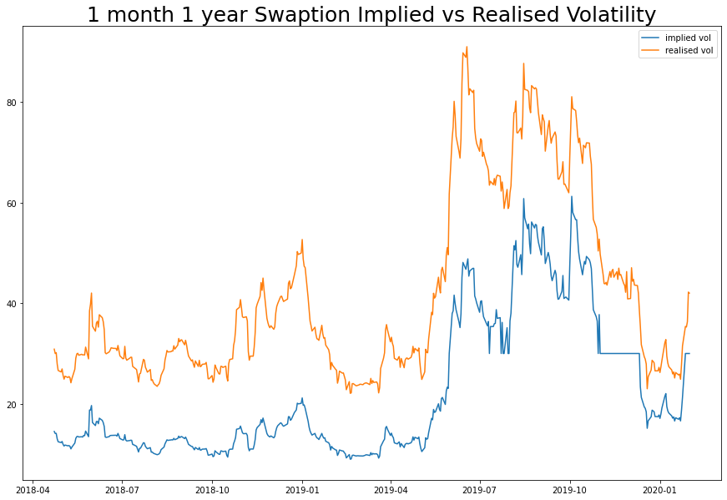*

Worth mentioning is the significant difference between our implied volatilities with the long-tenor swaps compared to their realized volatilities. This difference is caused by the swaption price and the underlying swap rate’s differences. They are too large for the numerical optimizer to reliably extract the accurately implied volatilities.

***Figure 4:***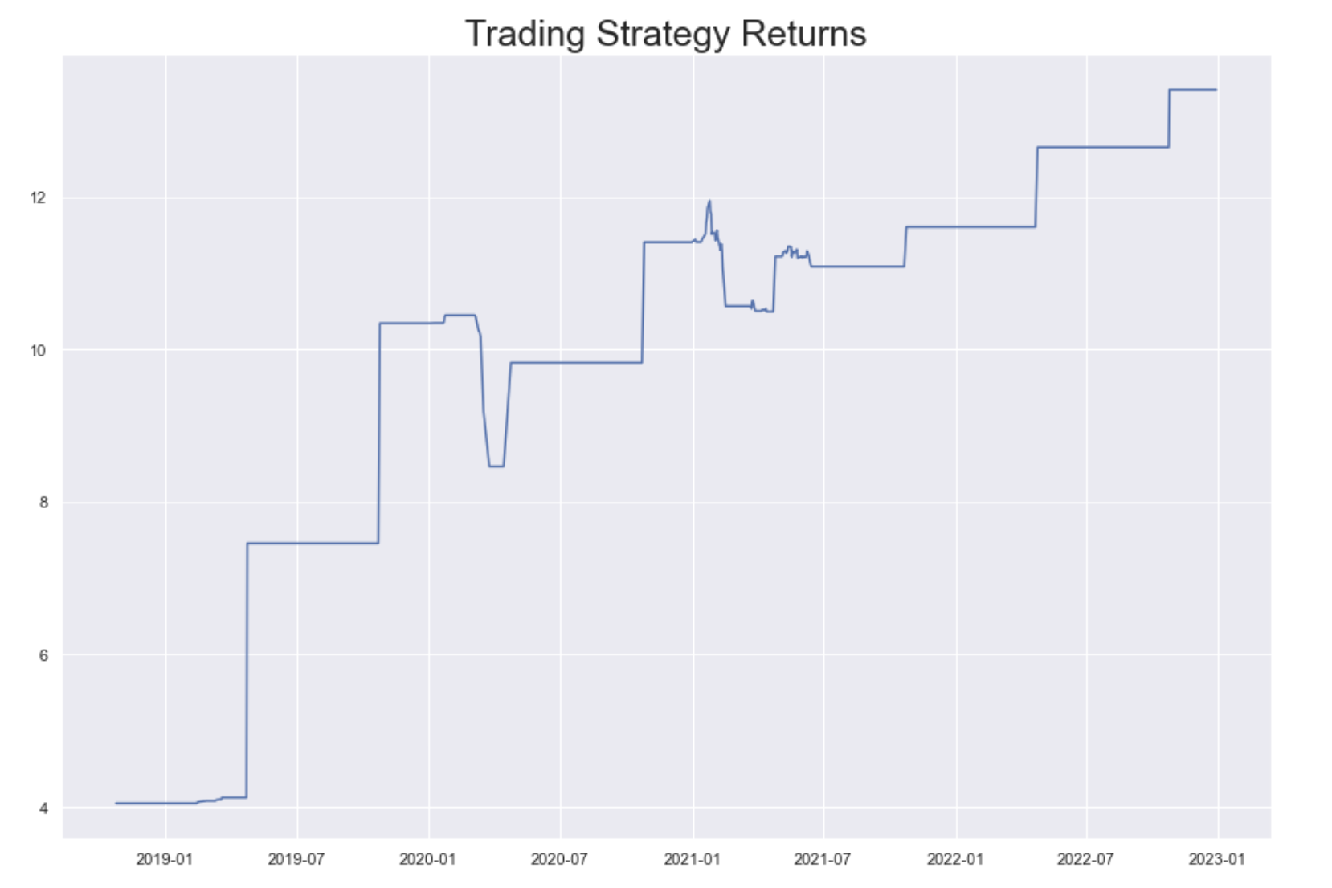

The trading signals generated by the long/short momentum strategy have long periods of no signals or holding signals which explains the horizontal portions of the above results graph. The sudden peaks in the returns occur due to a surge of signals being generated in a short period of time due to swings in the underlying causing the Moving Average to take highly directional positions.

Our results indicate a 1200% return over the 5-year period which is unrealistic, however, this is occurring due to the Algorithm assuming near-perfect market timing. Each moving average period acts independently of the next in terms of current holding and assumes any potential profits from the previous period have been completely captured. While the algorithm is rather naive, it does prove that creating a trading strategy on Implied Volatilities of Swaptions is not only possible but can be highly profitable as well. Another drawback to our strategy is not considering the Expiries of the options. Our portfolio of options consists of 1m and 3m expiry options across a period of 5 years, however, we are not taking into consideration the buying date of the options to track when the option finally expires and are instead treating the Options as an asset class of its own with no expiry, only volatilities acting as asset price.

# **Summary**

First, our methods are working very well. We get similar trends in our model implied volatilities and the realized volatilities without using any regression model or machine learning. Furthermore, our trading strategies are generating great profits throughout the maturity of the swaps, especially for the 1-year swap because ​​shorter-term swaps are more sensitive to changes in interest rates and economic data releases.

However, although the trends of implied volatility and realized volatility are similar, they are on different scales. This is because the realized volatilities and the implied volatilities calculated on Bloomberg include many random variables that we were not able to account for in our project such as the floating leg of the swap (LIBOR Rate) and the yield curve.

Furthermore, we encountered challenges in obtaining the implied volatility of swaption for some expiries due to the large difference between the swaption premium and underlying swap rates. This created numerical optimization issues in Python, where the optimizer was unable to effectively extract the implied volatilities without running into overflow and underflow issues. Therefore, we mainly focus on the 1-month and 3-month expiry swaptions in this project.

Lastly, it would be preferred to split the data into a training period and one testing period for backtesting which would ultimately give us more accurate results. (Thakre)

# **References**

Cesari, Riccardo och Massimiliano Marzo. ”Oxford Academic.” February 2013. *17 Trading Strategies, Portfolio Monitoring, and Rebalancing.* May 2nd, 2023.

Kelliher, Chris. *Quantitative Finance with Python*. Boca Raton: CRC Press, 2022.

Liu, Amanda och Jinming Xie. ”BIS.” January 25th, 2023. *Forecasting swap rate colatility with information from swaptions.* May 2nd, 2023.

Mujeeb, o.a. *Genetic Algorithms - Final Project*. MF703 Programming for Mathematical Finance. Boston: Boston University, 2022.

Thakre, Chinmay. *Homework 4*. Code. Boston: Boston University, 2023.